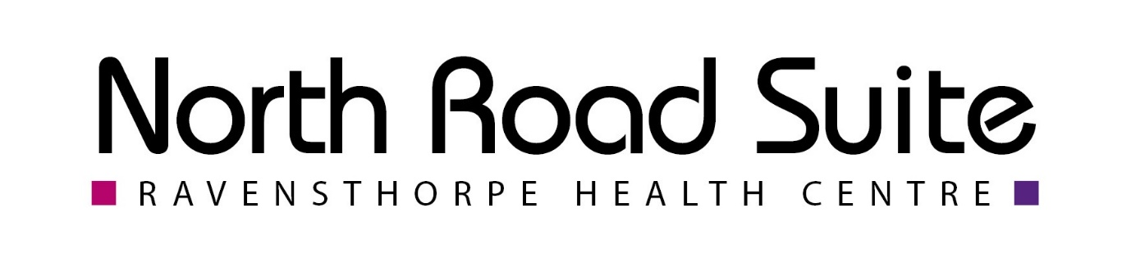
North Road Suites November Newsletter

🌟 November Awareness Month – Let’s Talk Health & Kindness
November is full of awareness campaigns — from men’s health to winter wellbeing. Here’s what’s happening this month 👇

💜 Pancreatic Cancer Awareness Month
Pancreatic cancer often has no early symptoms, making it hard to detect. Knowing what to look for could save a life.
Symptoms include:
• Unexplained upper abdominal pain
• Sudden weight loss or loss of appetite
• Indigestion or bloating
• Nausea or vomiting after fatty foods
• Fatigue or weakness
If you’re concerned, please contact your GP.
👉 https://www.pancreaticcancer.org.uk/information/signs-and-symptoms-of-pancreatic-cancer

🥸 Movember – Men’s Health & Mental Health
⚠️ Trigger warning: mental health and suicide.
Did you know 3 out of 4 suicides in the UK are by men? Movember encourages open conversations about men’s health and wellbeing.
Grow a moustache, start a chat, and check in on a mate who might be struggling.
👉 https://uk.movember.com/men-s-health/spot-the-signs
💬 Tip: Share local support groups like Andy’s Man Club or Dads’ Groups.

❄️ Winter Weather Warnings – Stay Warm & Well
Feeling the chill? Staying warm is key for your health this winter.
Top tips:
🧣 Layer up with thin clothing
☕ Enjoy plenty of hot drinks
🧤 Cover your hands, feet, and head
🚶 Keep moving
💧 Avoid alcohol
💰 Check if you’re eligible for the Winter Fuel Payment
👉 https://www.ageuk.org.uk/information-advice/health-wellbeing/keep-well-this-winter/stay-healthy-in-winter/
👉 https://www.gov.uk/winter-fuel-payment
💡 Tip: Look out for local warm spaces, community cafés, or soup kitchens.

🌬️ Lung Cancer Awareness Month
Lung cancer can affect anyone — not just smokers.
If you’ve had any of these symptoms for more than 3 weeks, speak to your GP:
• Persistent cough
• Coughing up blood
• Chest pain or shortness of breath
• Unexplained weight loss or fatigue
👉 https://www.macmillan.org.uk/cancer-information-and-support/lung-cancer/signs-and-symptoms-of-lung-cancer

👄 Mouth Cancer Awareness Month
Mouth cancer can start anywhere in the mouth — often the tongue or gums.
Look out for:
• Ulcers that don’t heal after 3 weeks
• Red or white patches
• Pain or swelling in the mouth
Early diagnosis saves lives.
👉 https://www.macmillan.org.uk/cancer-information-and-support/head-and-neck-cancer/mouth-cancer

💻 Social Media Kindness Day – 9th November
A reminder to stay kind online 💙
Our staff are people too, doing their best under pressure.
If you have feedback or concerns, please contact the Practice Manager directly — we’re always happy to help.

💙 Anti-Bullying Week – 10th to 14th November
40% of children experienced bullying last year — both online and in person.
Look out for:
- Mood or behaviour changes
- School avoidance
- Damaged belongings
- Unexplained bruises
Let’s use our #PowerForGood to stop bullying together 💪

🏳️‍⚧️ Transgender Awareness Week – 13th to 19th November
🌈 Transgender Day of Remembrance – 20th November
A time to support and celebrate our trans community.
Be an ally:
✨ Respect pronouns
🎧 Listen to trans voices
📖 Learn about gender identity and expression
👉 https://www.hrc.org/campaigns/transgender-awareness-week-transgender-day-of-remembrance

♿ Disability History Month – 14th Nov to 20th Dec
Celebrating the history, achievements, and voices of disabled people — while continuing to challenge stigma and promote inclusion.
Let’s learn, listen, and take action 💪

🍽️ UK Malnutrition Week – 17th to 23rd November
Malnutrition affects millions in the UK and can happen for many reasons — including isolation and rising living costs.
If you’re concerned about yourself or someone else, please reach out for support.
👉 https://www.nhs.uk/conditions/malnutrition/treatment/

🧘 National Self-Care Week – 17th to 23rd November
Self-care is essential for both mental and physical well-being.
Ideas to try:
🌿 Go for a mindful walk
🧘 Try meditation
💬 Talk to someone you trust
😊 Do something you enjoy
👉 https://nshcs.hee.nhs.uk/training-support-hub/trainee-wellbeing-handbook/self-care-ideas-to-get-you-started/
💡 Tip: Join local meditation, yoga, or self-care groups.

🍭 Sugar Awareness Week – 17th to 23rd November
Most of us eat more sugar than we think!
Tips to cut back:
🥤 Swap sugary drinks for water
🍎 Choose unprocessed snacks
🔎 Read food labels carefully
👉 https://www.nhs.uk/healthier-families/food-facts/nhs-food-scanner-app

💊 Antimicrobial Resistance Awareness Week – 18th to 24th November
Antibiotic resistance is a growing threat. Help keep antibiotics working for when they’re really needed:
💊 Take as prescribed
⏰ Never skip doses
✅ Complete the full course
💉 Stay up to date with vaccinations
Every action helps protect lives.

👨 International Men’s Day – 19th November
A day to celebrate positive male role models and raise awareness about men’s health.
Did you know:
• Men are less likely to seek help for health issues
• Suicide is one of the top causes of death for men under 50
Let’s encourage open conversations.
👉 https://ukmensday.org.uk/

❤️ Carers’ Rights Day – 20th November
Every day, around 12,000 people become unpaid carers.
This year’s theme: “Know your rights, use your rights.”
If you’re a carer, there’s support available — you don’t have to do it alone.
👉 https://www.carersuk.org/news-and-campaigns/our-campaigns/carers-rights-day/

💫 Let’s End November with Awareness, Compassion & Connection
Small actions — a conversation, a check-in, or a kind word — can make a huge difference this month.
Stay safe, stay warm, and look out for one another 💙

